Global Admissions Performance Dashboard
Dashboard Design Documentation

Tool  Google Looker Studio | Data Source  Google Sheets | Audience  Admissions Management & Leadership

1. Purpose and Goals
The Global Admissions Performance Dashboard is a single-page, real-time reporting tool built in Google Looker Studio to give admissions teams and institutional leadership a comprehensive, at-a-glance view of the global applicant pipeline.

Primary Purpose
- Track the total volume of applicants, admitted students, and pending decisions across all intake cycles.
- Monitor the global acceptance rate and understand how it varies by country, region, and academic program.
- Identify geographic concentration of applicants and evaluate outreach effectiveness by caller/agent.
- Support data-driven decisions for recruitment strategy, resource allocation, and enrollment planning.

Strategic Goals
- Provide leadership with an executive-level summary of the admissions funnel without requiring manual reporting.
- Enable drill-down filtering by Country, Intake Year, and Admission Status to answer specific operational questions.
- Surface program-level demand trends to inform curriculum planning and marketing spend.
- Benchmark outreach team performance by linking callers to application volume via Reference IDs.

Target Audience
The primary users are admissions directors, enrollment managers, and senior institutional leadership. Secondary users include outreach coordinators who monitor their own referral performance through the Outreach Metrics table.

2. Key Visuals and Why They Were Chosen

The dashboard uses five distinct visual types, each selected to answer a specific analytical question as efficiently as possible.

KPI Scorecards — Top Row
Total Applicants  5,000 | Total Admitted  3,256 | Total Pending  1,744 | Acceptance Rate  65.12% | # of Countries  96 | # of Regions  351

Six scorecards sit at the top of the dashboard displaying Total Applicants (5,000), Total Admitted (3,256), Total Pending (1,744), Acceptance Rate % (65.12%), # of Countries (96), and # of Regions (351). Scorecards were chosen because they deliver the most critical headline numbers instantly, without requiring the reader to interpret a chart axis. The gold-on-black styling ensures maximum visual contrast and draws the eye immediately upon loading the report.

Visual Inventory
Visual | Type | Purpose & Design Rationale
Country-Level Applications | Horizontal Bar Chart | Ranks the top applicant-sending countries (India: 2,684; USA: 489; Ghana: 412) from highest to lowest. A horizontal orientation is ideal here because country names are long text labels that would overlap on a vertical axis. The sorted order makes ranking immediately clear without scanning.(Only used top 7 Country)
Program Performance | Vertical Bar Chart | Compares applicant volume across academic programs (Business Analytics: 707; Computer Science: 607; Data Science: 337, etc.). A vertical bar chart suits this comparison because the programs are discrete categories of roughly similar name length. Side-by-side bars make volume differences easy to compare at a glance.(Only used top 7 Program Name)
Admission Outcomes | Donut / Pie Chart | Visualizes the split between Admitted (64.7%) and Pending (35.3%) applications. A donut chart is appropriate for this binary part-to-whole relationship — it communicates proportions more intuitively than a bar chart for two categories and leaves room for percentage labels.
Outreach Metrics | Ranked Table | Lists the top 5 outreach callers by Reference ID count (Jagdeep: 1,260; Swarna: 306; Ayesha: 144; Lavnaya: 96). A table is the right choice here because the data involves named individuals with precise counts — a chart would lose the specificity needed for individual accountability tracking.
Interactive Filters | Dropdown Controls (3) | Three filter controls (Country, Intake Year, Admission Status) are placed in the top-right of the header. Dropdown filters are chosen over sliders or date pickers because the underlying dimensions are discrete categorical values. Placing them in the header ensures they are visible at all times regardless of scroll position.

3. Page Layout and Design Logic

Layout Structure
The dashboard follows a strict top-to-bottom, left-to-right reading hierarchy across four horizontal zones:

Zone | Content | Design Intent
Zone 1 — Header | Title + 3 filter dropdowns | Establishes the report identity and houses all interactive controls. Gold text on black creates a strong anchor. Filters are right-aligned to separate them from the title while keeping them within the header zone.
Zone 2 — KPIs | 6 scorecard tiles | Full-width row of key metrics provides an immediate executive summary before any chart is read. Consistent tile sizing communicates equal importance across all six metrics.
Zone 3 — Charts | 2 bar charts side by side | The two largest visuals occupy equal half-width columns. Geographic data (countries) sits left; programmatic data sits right, creating a natural 'where vs. what' segmentation for the reader.
Zone 4 — Detail | Donut chart (left) + table (right) | Outcome-level analysis (admitted vs. pending) pairs with operational detail (outreach caller performance). The donut communicates proportion quickly; the table provides the actionable names and numbers that follow.

Color Scheme & Branding
The dashboard uses a deliberate dark-theme palette built around three core colors:
- Black (#000000) — page and header background, creates focus and reduces visual noise.
- Gold / Amber (#F5A800) — primary accent for titles, chart bars, KPI values, and table headers. Provides high contrast against black and signals importance.
- White / Light cream — secondary text and KPI labels, ensuring legibility against dark backgrounds.

This palette is consistent with premium, institutional branding. The high-contrast gold-on-black combination also ensures accessibility for users viewing on standard monitors in brightly lit environments.

4. Data Flow

The following table describes the end-to-end journey of data from its original source to the final visualizations presented in the dashboard.

Step | Layer | Description
1. Source | Google Sheets | Raw applicant data is stored in Google Sheets, containing fields such as applicant name, country, region, program of interest, admission status, intake year, and caller/outreach reference information.
2. Connection | Looker Studio Connector | Looker Studio connects directly to the Google Sheets file via the native Google Sheets data connector. No intermediate database or ETL pipeline is required.
3. Transformations | Calculated Fields & Filters | Calculated fields are applied within Looker Studio to derive metrics such as Acceptance Rate % (Admitted / Total Applicants × 100). Dimension filters for Country, Intake Year, and Admission Status are configured as interactive controls.
4. Aggregations | Count & Sum operations | Visuals aggregate data using COUNT (for applicants, countries, regions) and SUM/percentage breakdowns (for admission outcomes). Program-level and country-level groupings are applied automatically by the chart components.
5. Visuals | Charts & Scorecards | Aggregated data is rendered into 6 KPI scorecards, 2 bar charts, 1 donut chart, and 1 ranked table. All visuals respond dynamically to the 3 interactive filter controls at the top of the dashboard.

Key Fields Used
- Applicant Status — used to compute Admitted vs. Pending split and Acceptance Rate %.
- Country & Region — used to build the country-level bar chart and populate the Country filter.
- Program — used to build the Program Performance bar chart.
- Intake Year — used to populate the Intake Year filter for time-based segmentation.
- Caller_Name & Reference_ID — used to build the Outreach Metrics ranked table.

5. Challenges Encountered During Creation

1. Data Skew in Country-Level Distribution
India accounted for 2,684 of the 5,000 total applicants — more than five times the next largest source country (USA at 489). This extreme skew compressed all other countries' bars in the horizontal bar chart, making smaller values visually difficult to compare. To address this, the chart was configured with explicit data labels on each bar so that precise values remained readable regardless of bar length.

2. Handling 'NA' Values in Outreach Data
The Outreach Metrics table shows 'NA' as the top entry with a Reference_ID count of 3,194 — representing applicants with no assigned caller. This required a design decision: whether to filter out NA values or surface them as a data quality indicator. The decision was made to retain NA to make the gap in outreach coverage visible to leadership, prompting action on unassigned leads.

3. Balancing Summary vs. Detail in a Single Page
Fitting six KPI scorecards, two bar charts, a donut chart, and a ranked table onto a single dashboard page without creating visual clutter required careful sizing and alignment. Elements were organized into clearly defined zones with consistent gutters, and the header filter controls were right-aligned to avoid competing with the title.

4. Program Name Truncation
Several academic program names (e.g., 'Business Analytics', 'Health Information Management', 'Information Systems') were too long to display in full on the X-axis of the Program Performance bar chart at the chosen chart width. Looker Studio automatically truncated these labels with ellipses. To mitigate this, the chart was sized to the maximum available width on the right half of the dashboard, and tooltips provide the full program name on hover.

5. Filter Coordination Across All Visuals
Ensuring that all three dropdown filters (Country, Intake Year, Admission Status) dynamically controlled every visual on the page — including both bar charts, the donut, the table, and the scorecards — required explicit configuration of each filter's scope within Looker Studio. Default filter behavior can be component-scoped, so each control was manually set to apply across all data components to ensure a consistent, coherent filtered view.

6.Screenshots and Dashboard Link

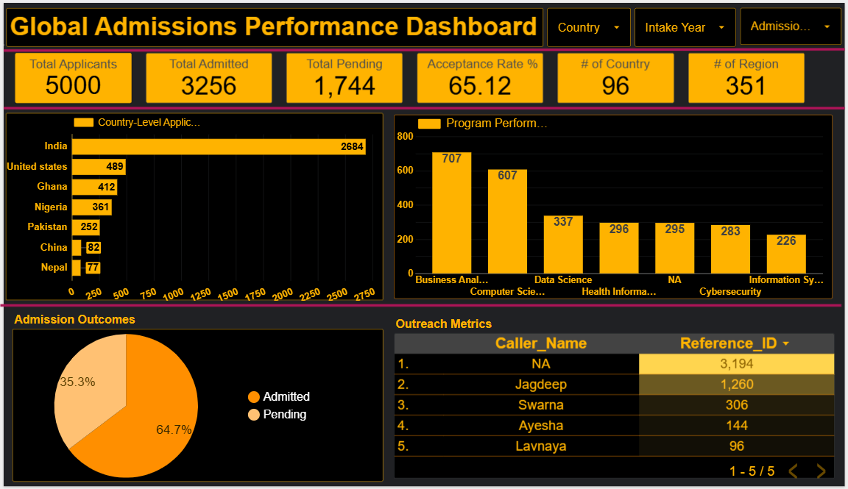

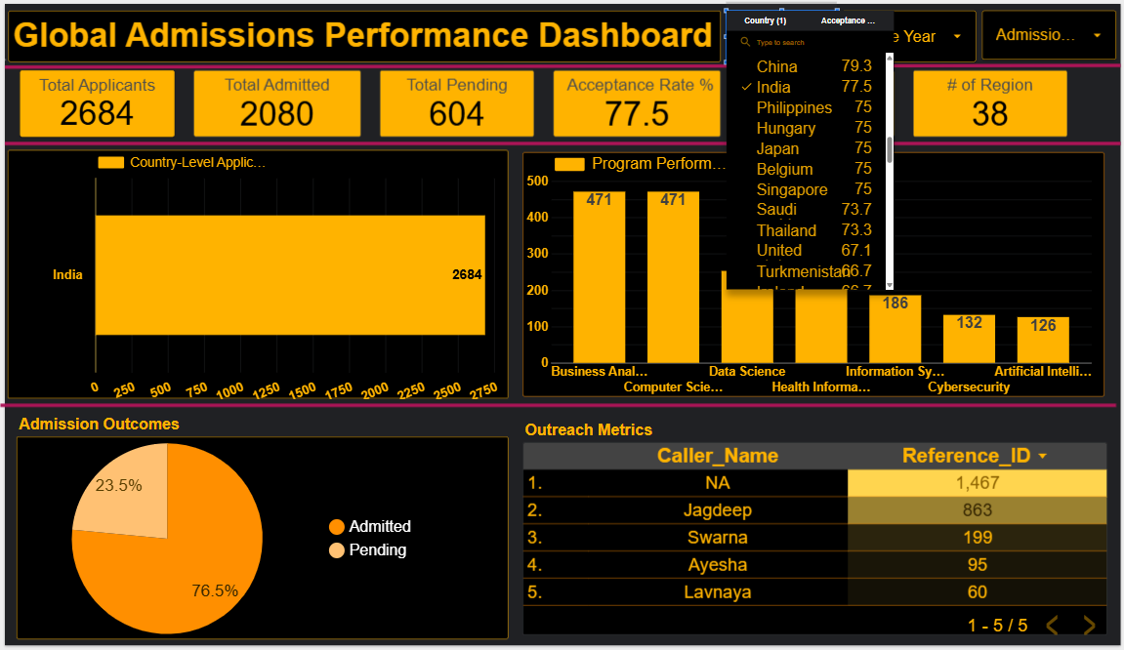

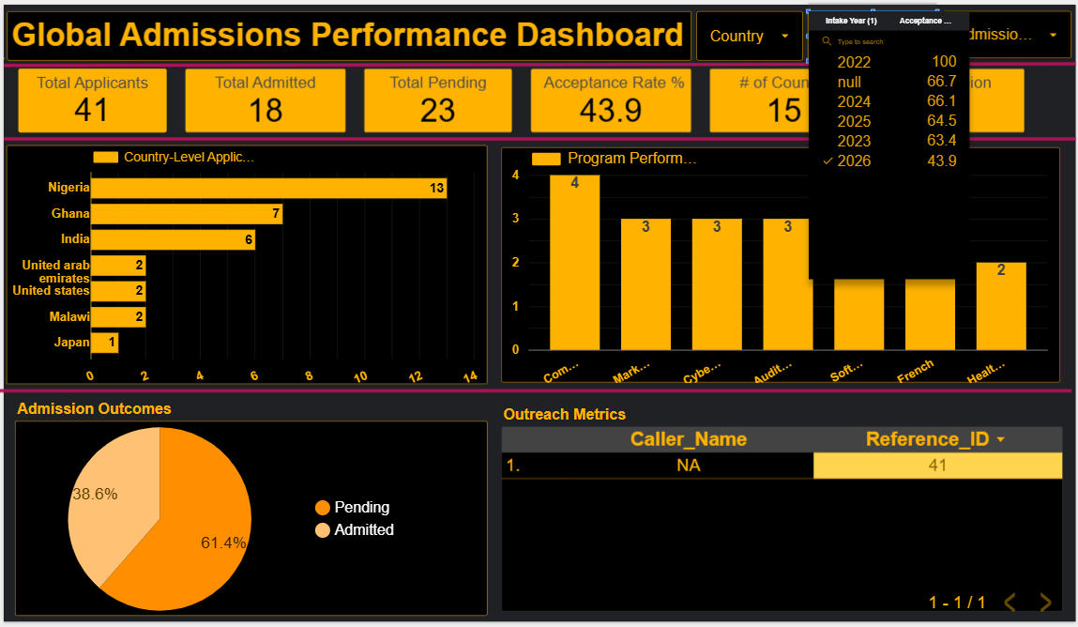

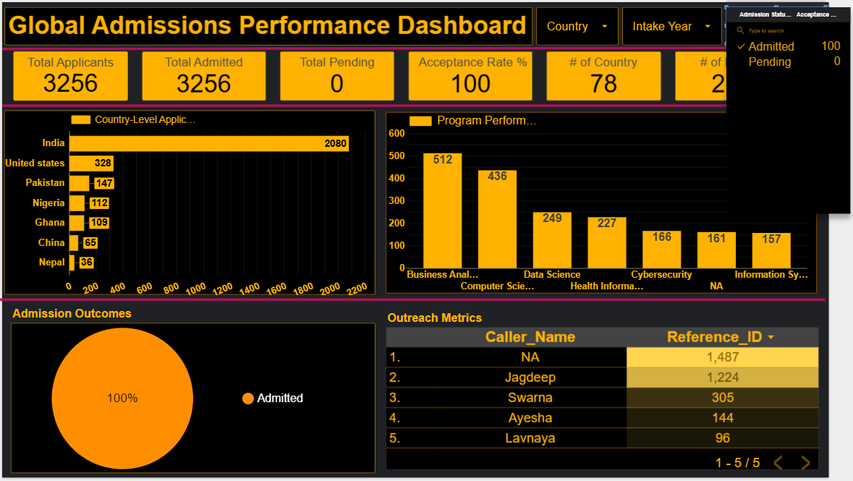

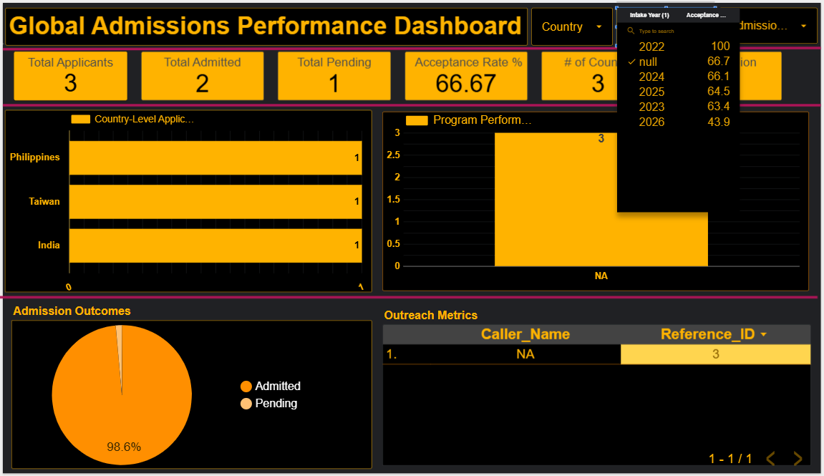

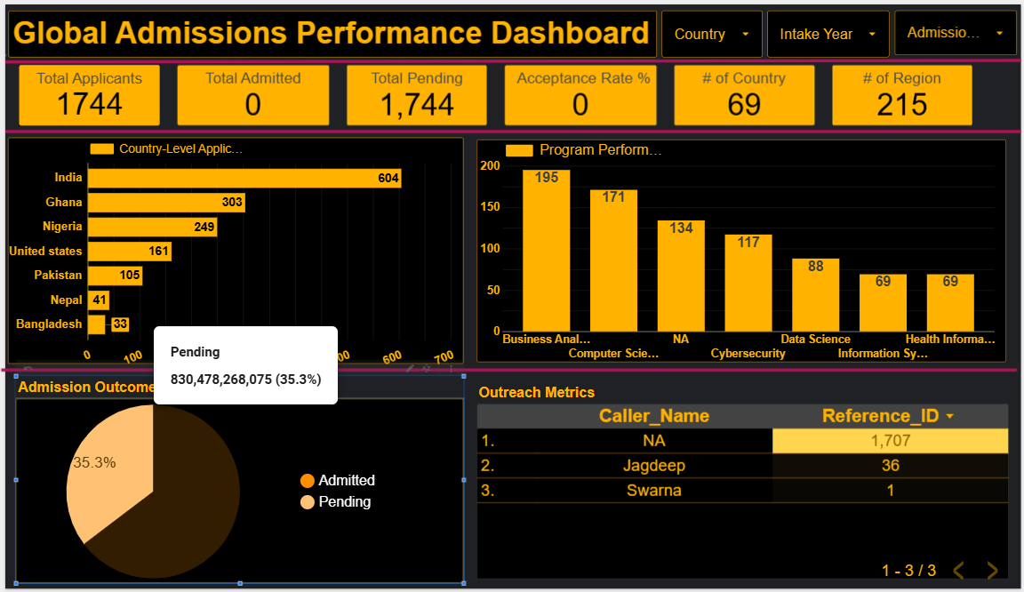

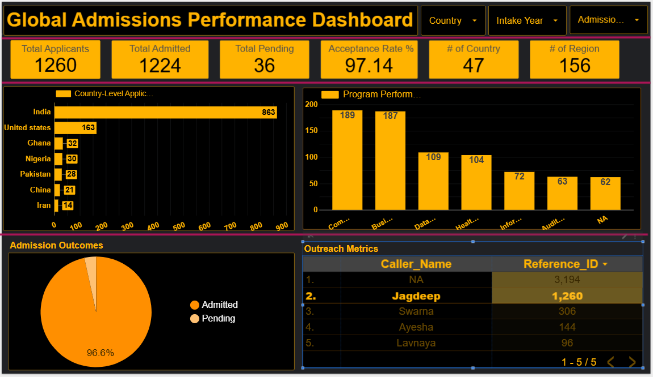

Link:-
https://lookerstudio.google.com/reporting/8711e03e-47b6-4cbf-8e31-e2f3d50fb948

End of Document

